Working with a Child’s Low Appetite Due to ADHD Medication
TIPS

- Take advantage of your child’s natural appetite at the time of day when the medication hasn’t yet kicked in, and when it’s wearing off – usually first thing in the morning or at dinnertime.
- If the medication is in full effect at lunchtime, very little may be eaten. Offer an after-school snack, being conscious of the amount
so it doesn’t impact dinner.

- If you feel that the medication schedule should be adjusted, speak to your physician or health care provider. For example, if your child’s appetite is severely impacted during the week, you may opt not to give them the medication on the weekend.

- Large snacks right before bed may reduce appetite for breakfast the next morning.
WHAT TO PROVIDE
- A relaxed, low stress, low pressure, and supportive environment for eating.
- If your child is underweight focus on higher calorie, nutrient-rich foods.
- Consider adding butter, margarine, cheeses, or healthy oils to pasta, potatoes, rice, and bread. Nut butters are a good ‘at home’ option.


KEY NUTRIENTS TO SUPPORT BRAIN FUNCTION
- Iron, zinc, magnesium, omega-3’s, fibre, folate, and healthy fats (see handouts).

COMBINE 2-4 FOOD GROUPS PER SNACK/MEAL FOR ADDED NUTRITION
- For example: banana + peanut butter; Greek yogurt + granola; French toast + berries; whole wheat waffles + scrambled eggs; animal crackers + raisins; egg, cheese, and salsa wrap.
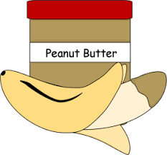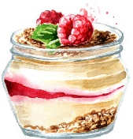

SOME CHILDREN PREFER STRONGER FLAVORED FOODS:
- For example: parmesan cheese, hot sauce, garlic, olives. Experiment to see what your child enjoys.
SERVING A NEW FOOD?
- Always serve a new food with a food your child already enjoys.
- If your child doesn’t want to try the new food, that’s okay! It may take 10-50 times of seeing the food before a child will taste.
- If your child is not interested in trying the food yet, try using the other 4 senses:
How does it look (sight)– color, texture? How does it smell (smell)? What does it feel like (touch)? What does it sound like (hearing) when you (the parent) eat it?
GET CURIOUS
- Many children enjoy learning about and helping plant a garden.
- At the grocery store, challenge your child to spot as many different colored fruits or vegetables as possible.
- Consider involving your child in age-appropriate meal preparations.
